# Hotel

# Use-Case: Hotel Booking System

1. Brief Description

The use of the hotel reservation system to test the functionality of the entire hotel booking system is used. This software can be used by the user for hotel services, for example for booking a room or other hotel services. First, the user can book a room and receive the booking confirmation number required at check-in. After registration, the user can add other hotel services by choosing a particular service. Upon departure, the user can pay the full amount, including extra services.

1. Actor

User

1. Pre-Conditions

* The main menu is displayed including room type information as Single, Double, Twin share.
* B: Book a Room
* C: Check In
* R: Record Service
* D: Check Out
* Q: Quit

Able to enter the one of the selected latter (B, C, R, D or Q).

1. Normal Flow

The use case begins when user type selected latter from the main menu.

|  |  |
| --- | --- |
| Actor | System |
|  | 1. Able to enter the one of the selected latter (B, C, R, D or Q). |
| 1. Type (B) for Book a Room. | 1. Able to enter phone number. |
| 1. Enter phone number | 1. Able to enter guest name. |
| 1. Enter guest name | 1. Able to enter guest address. |
| 1. Enter guest address | 1. Show the following :  * Show customer entered details. * Show room type options. * Able to enter room type selection. |
| 1. Enter selected room type | 1. Able to enter number of occupants. |
| 1. Enter number of occupants | 1. Able to enter arrival date  * Enter day (DD) * Enter month (MM) * Enter year (YYYY) |
| 1. Enter arrival date day/month/year accordingly | 1. Able to enter length of stay. |
| 1. Enter length of stay | 1. Show the cost and prompt to enter the credit card details as :  * Choose credit card type from the options. * Enter credit card number. * Enter CCV number |
| 1. Enter credit card details accordingly | 1. Display following:  * Booking details including cost * Confirmation Number |
| 1. Hit <enter> to continue | 1. Booking Completed |
| **Display main menu again** | |
|  | 1. Prompt to enter the one of the selected latter (B, C, R, D or Q). |
| 1. Type (C) for Check in | 1. Prompt to enter confirmation number. |
| 1. Enter confirmation number | 1. Display following:  * Display booking details. * Prompt to confirm check in? (y/n) |
| 1. Enter (y) to confirm check in | 1. Display check in confirmed |
| 1. Hit <enter> to continue | 1. Checking in completed |
| **Display main menu again** | |
|  | 1. Prompt to enter the one of the selected latter (B, C, R, D or Q). |
| 1. Type (R) for record services | 1. Display following:  * Display services types * B: Bar Fridge * R: Restaurant * S: Room Service * Prompt to enter service type |
| 1. Enter service type | 1. Prompt to enter service cost |
| 1. Enter service cost | 1. Display Services details including cost |
| 1. Hit <enter> to continue | 1. Record service completed |
| **Display main menu again** | |
|  | 1. Prompt to enter the one of the selected latter (B, C, R, D or Q). |
| 1. Type (D) for check out | 1. Prompt to enter room number |
| 1. Enter room number | 1. Display following:  * Display booking details * Display service charges cost * Display total cost * Prompt to accept charges? (y/n) * Remove the room from the active booking list. |
| 1. Enter (y) to accept charges | 1. Display the cost and prompt to enter the credit card details. |
| 1. Enter credit card details | 1. Display debited amount. |
| 1. Hit <enter> to continue | 1. Display checking out completed. |
| **Display main menu again** | |

The use case ends.

1. Unsuccessful Flows

|  |  |
| --- | --- |
| **Display main menu again – Record service** | |
|  | 1. Prompt to enter the one of the selected latter (B, C, R, D or Q). |
| 1. Type (R) for record services | 1. Display following:  * Display services types * B: Bar Fridge * R: Restaurant * S: Room Service * Prompt to enter service type |
| 1. Enter service type | 1. Prompt to enter service cost |
| 1. Enter service cost | 1. Display following:  * Services details including cost * **Store cost value.** |
| 1. Hit <enter> to continue | 1. Record service completed |
| **Display main menu again – Checking out** | |
|  | 1. Prompt to enter the one of the selected latter (B, C, R, D or Q). |
| 1. Type (D) for check out | 1. Prompt to enter room number |
| 1. Enter room number | 1. Display following:  * Display booking details * Display service charges cost **$0.00** * Display total cost **$0.00** * Prompt to accept charges? (y/n) * **Remove the room from the active booking list.** |
| 1. Enter (y) to accept charges | 1. Display the cost and prompt to enter the credit card details. |
| 1. Enter credit card details | 1. Display debited amount **$0.00**. |
| 1. Hit <enter> to continue | 1. Display checking out completed. |

**5.1 First reported bug: At check out record service cost shown is $0.00**

**Appropriate action is to show the required amount at time of Check Out instead of $0.00.**

The use of the variable is not correct, so the costs do not go to the method that could save the value and the test result on the device is not successful either.

**Unit test output:**

The test result is not successful because of bug behavior because the method does not store the value, so the expected and actual results are different.

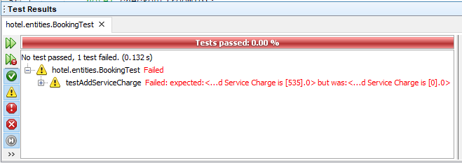

**Source code screenshot:**

The error is highlighted in the following screen shots. The addServiceCharges () method stores only the type of service, not the price, because output is the only type of service, but the cost of services is **$0.00**.

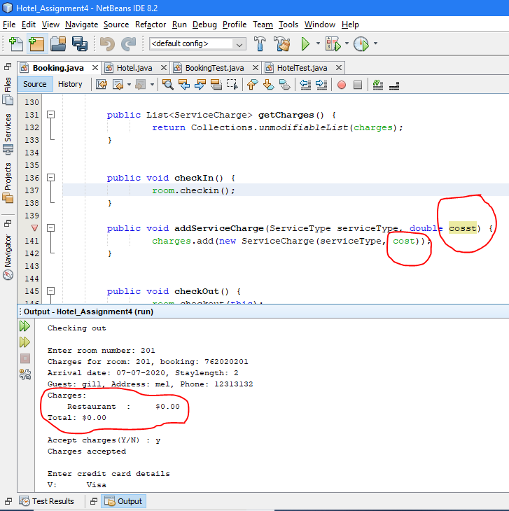

**5.2 Second reported bug: Possibility of change in the room service at the time of check out.**

**The appropriate action is to show that not booking available for the particular room.**

The implementation of the method is not correct, so the room remains active after checking, but it must be removed from the active list and the test results of the unit have failed for the same reason.

**Unit test output:**

The test result failed because of bug behavior because the removal method does not remove the interval from the active list. Therefore, the testFindActiveBookingByRoomID () method is still active because the test did not succeed as expected and the actual result is different.

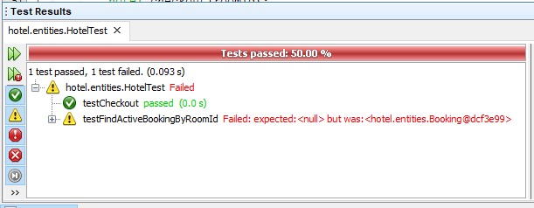

**Source code screenshot:**

The error is highlighted in the following screen shots. The payment method () does not remove the space from the active posting list, because the checkin () method adds the space (s) in the active list, allowing charging after the guest has checked that the room has never been removed from the active list .

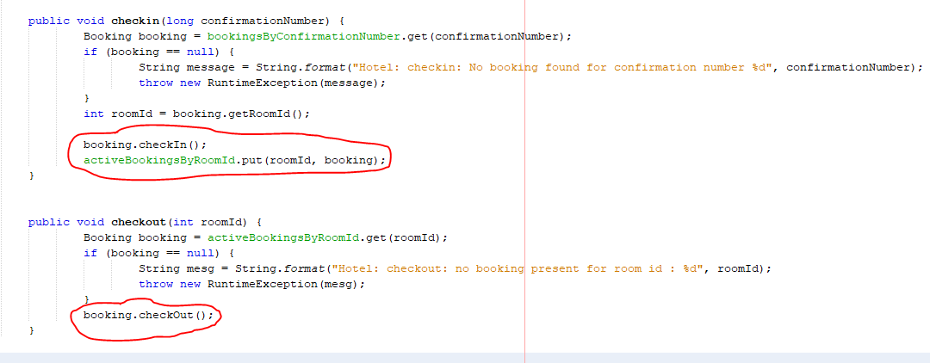

1. Key Scenarios
   1. Successful book a room.
   2. Successful check in.
   3. Unsuccessful record services.

* Does not passing the entered cost value to the required method for storing process.
  1. Unsuccessful check out.
* Does not remove the room from the active list.